# Apply filters to SQL queries

## Project description

[Describe what you accomplish through SQL.]

What I am accomplishing through SQL is investigating security issues in order to help keep the system secure. For this time around, there are some potential security issues which involve login attempts as well as employee machines. My task is to examine the organization data in the organization’s employees and log_in_attempts tables by using SQL filters to retrieve records from different datasets and investigate the potential security issues.

## Retrieve after hours failed login attempts

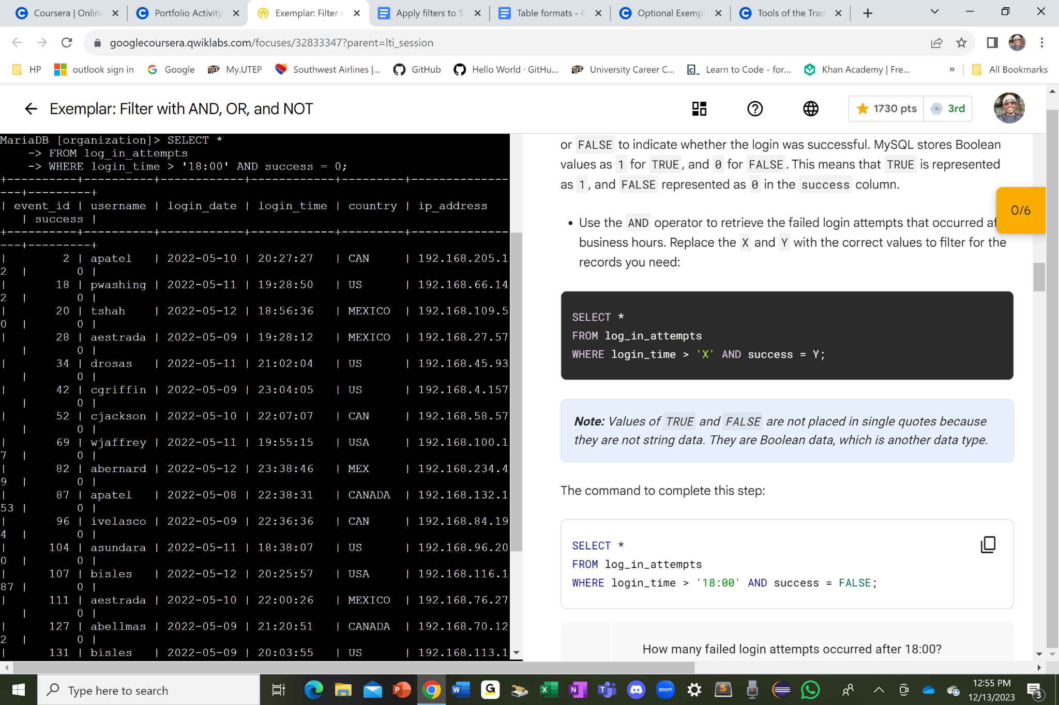

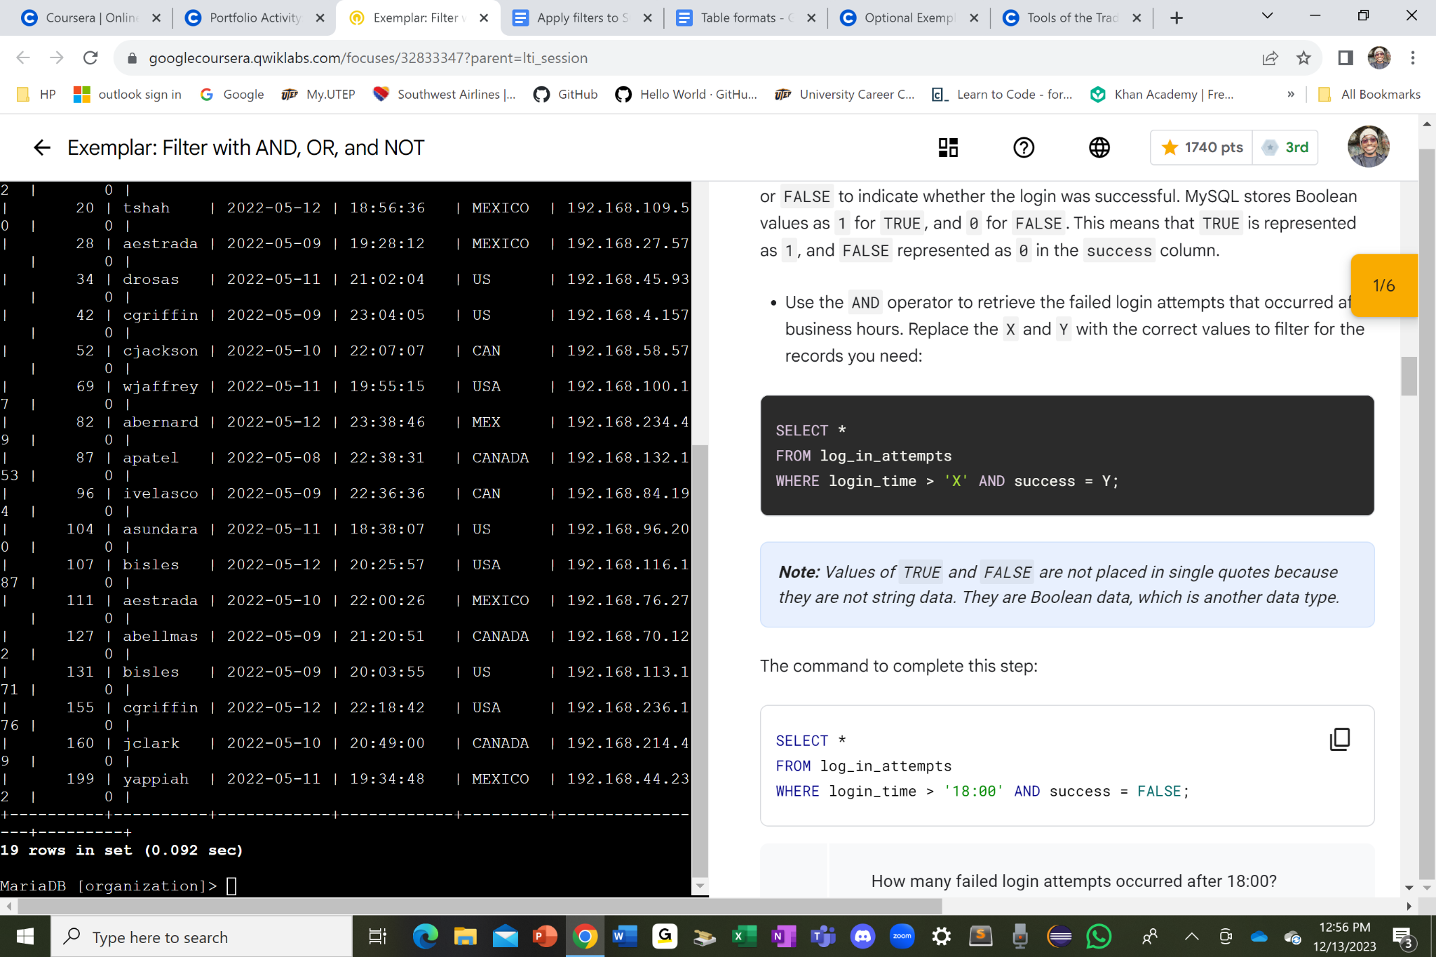

I used SELECT * command to select all the columns on the log_in_attempts table with the help of the asterisk after the word select in high capitalized letters. From there, I used the FROM log_in_attempts command to indicate where I am selecting the columns from this particular table that I am getting them from. Afterwards, I used the WHERE login_time > ‘18:00’ AND success = 0 command with a semicolon “ ; “ in the end of the whole command that I compiled to let the program to know that it is ready to run the whole command from the SELECT keyword to the semicolon.

When I run the command, it only shows the list of usernames with the login time after 18:00 and there are a total of 19 failed login attempts since at the bottom of the whole table, it stated that there are “19 rows in set” indicating that this is all the rows which the table had left with the used of the login_time > ‘18:00’ command in the WHERE clause. In other words, the table just narrows down to the list of usernames with the failed login attempts according to the time constraint which was placed in the WHERE clause.

## Retrieve login attempts on specific dates

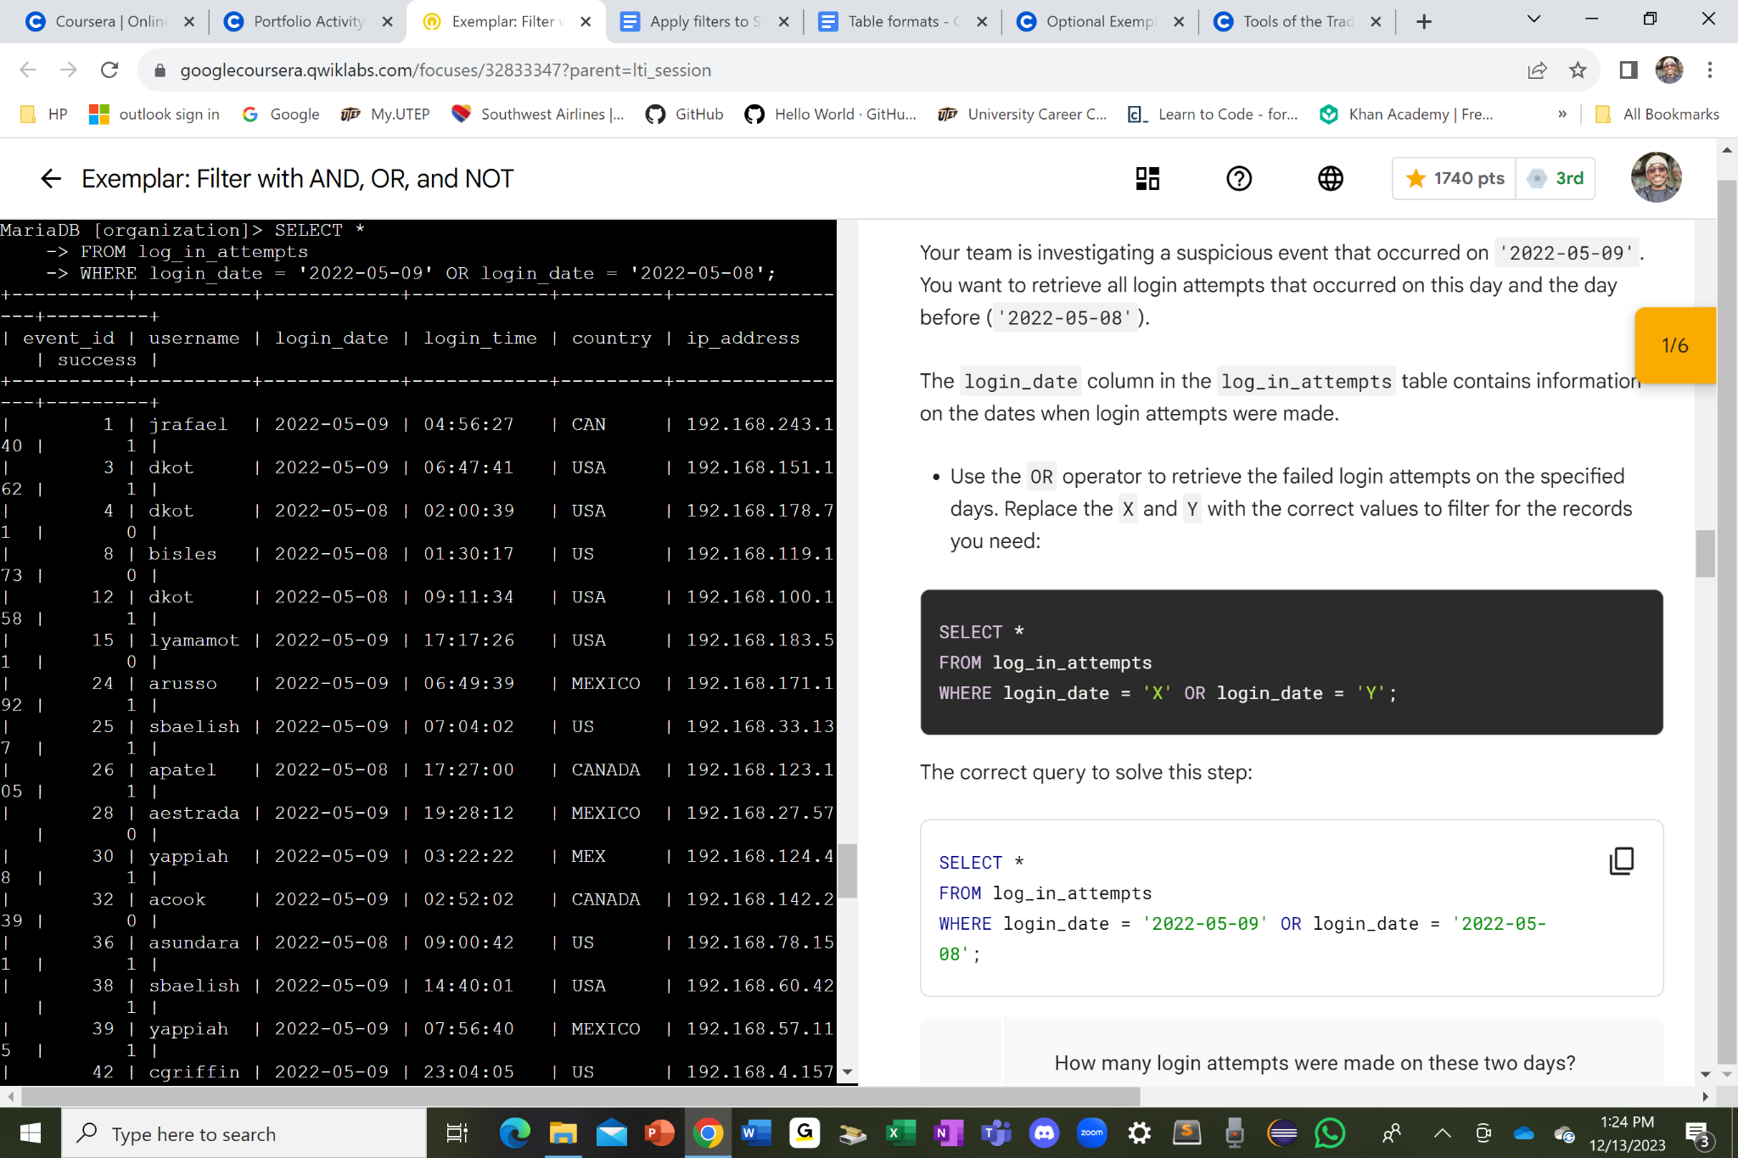

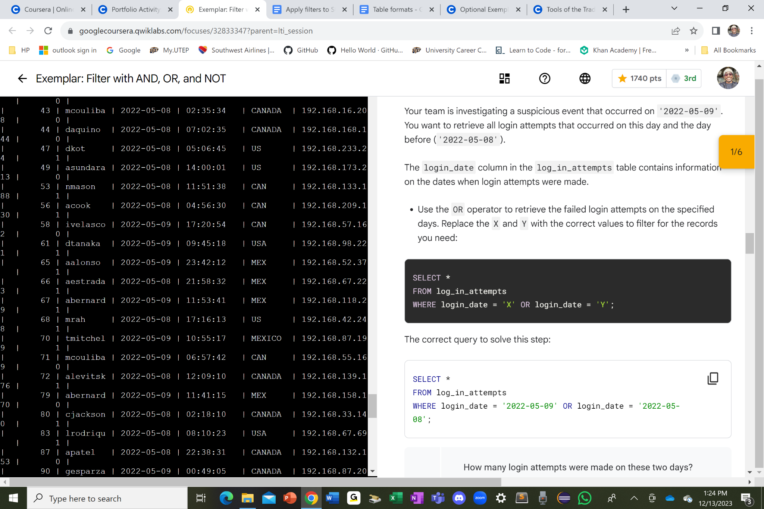

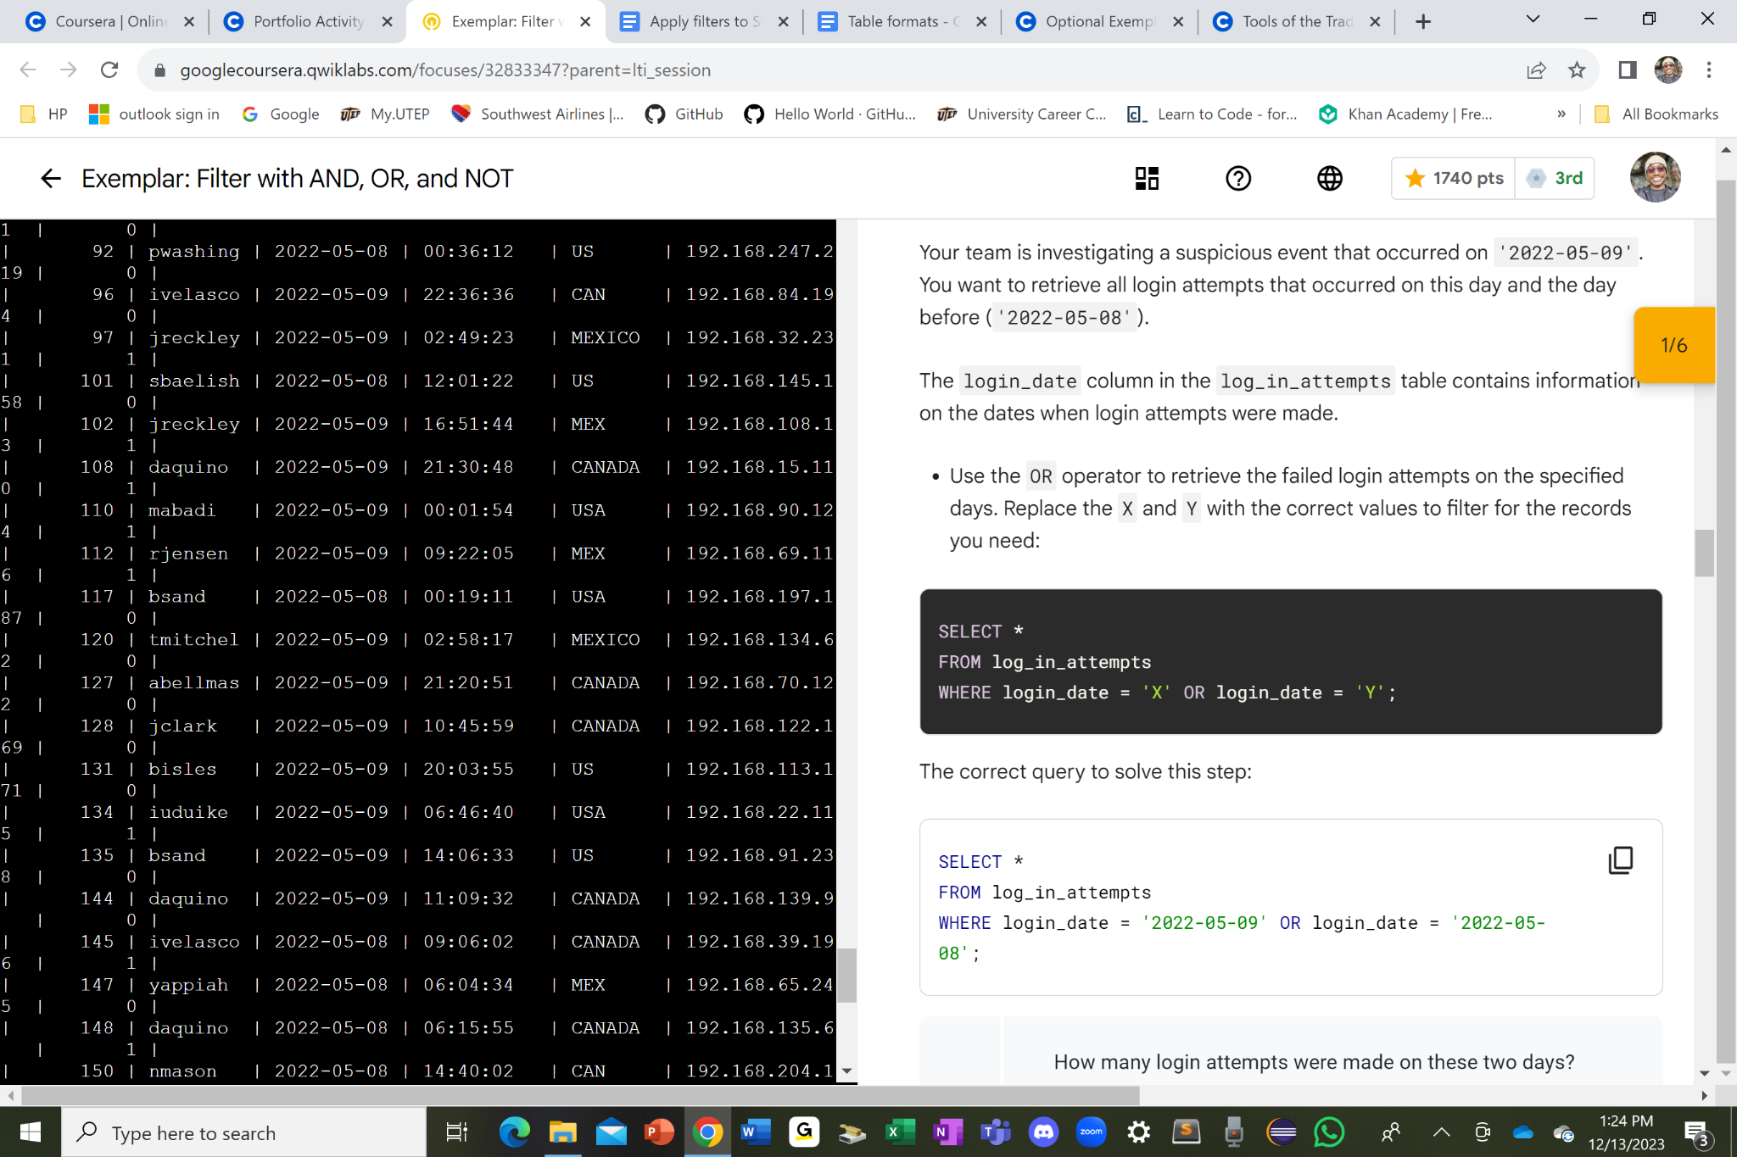

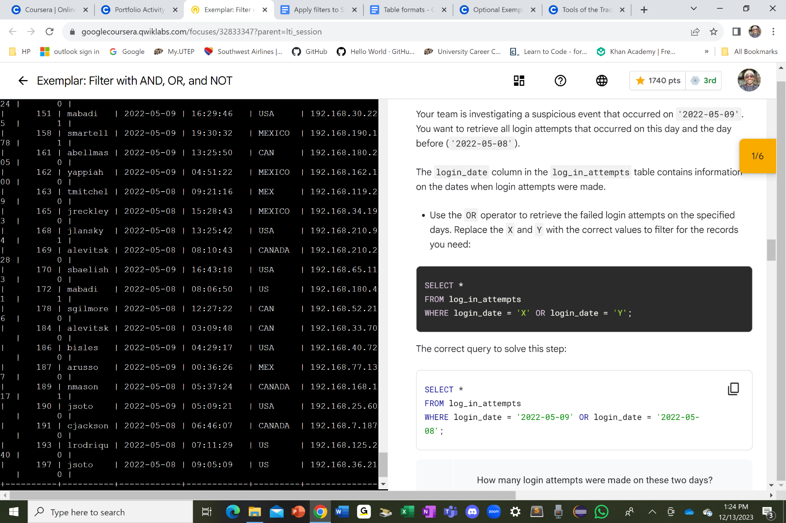

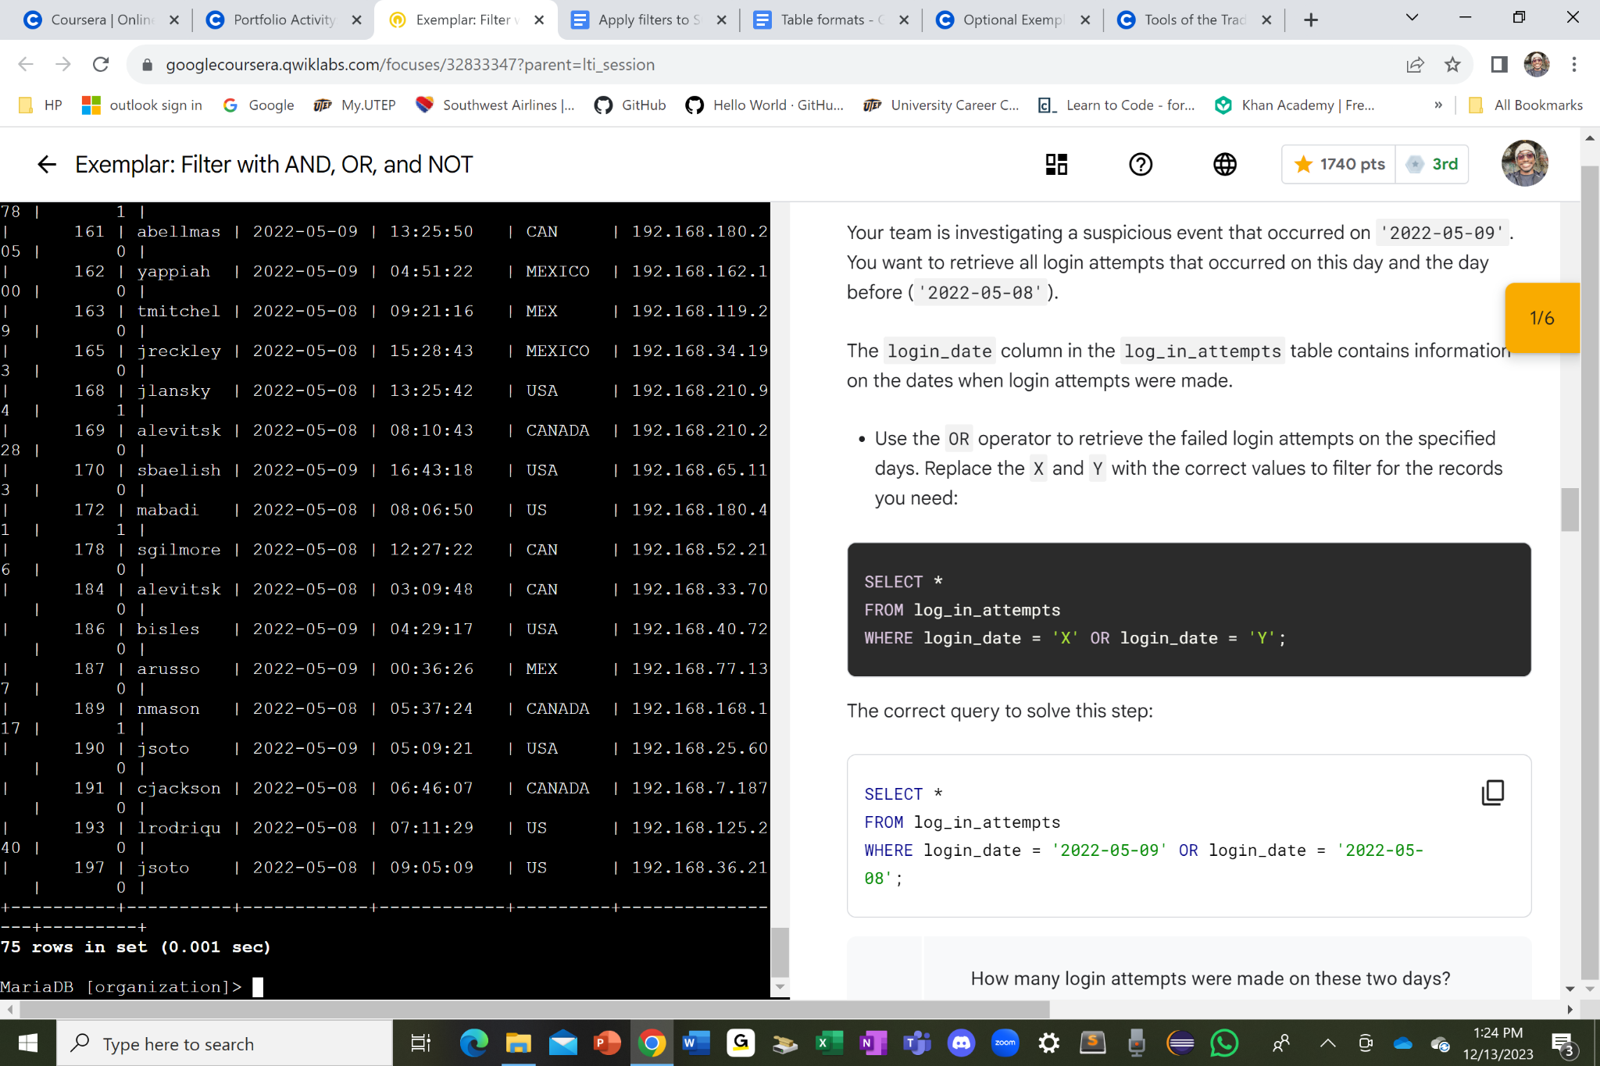

I first started off with the SELECT * command to select all the columns in the log_in_attempts table which I indicated where I selected the columns from with the FROM log_in_attempts right after the SELECT clause. From there, I used the WHERE login_date = ‘2022-05-09’ OR login_date = ‘2022-05-08’ command with the semicolon “ ; “ in the end to tell the program that it is ready to run.

As I compiled the whole command, the table has both the date ‘2022-05-09’ and ‘2022-05-08’ for some of the rows individually but not together in one row as a response to the WHERE clause which asks for the login_date to be either ‘2022-05-09’ or ‘2022-05-08’. Hence, why all the dates in the table are either ‘2022-05-09’ or ‘2022-05-08’.

## Retrieve login attempts outside of Mexico

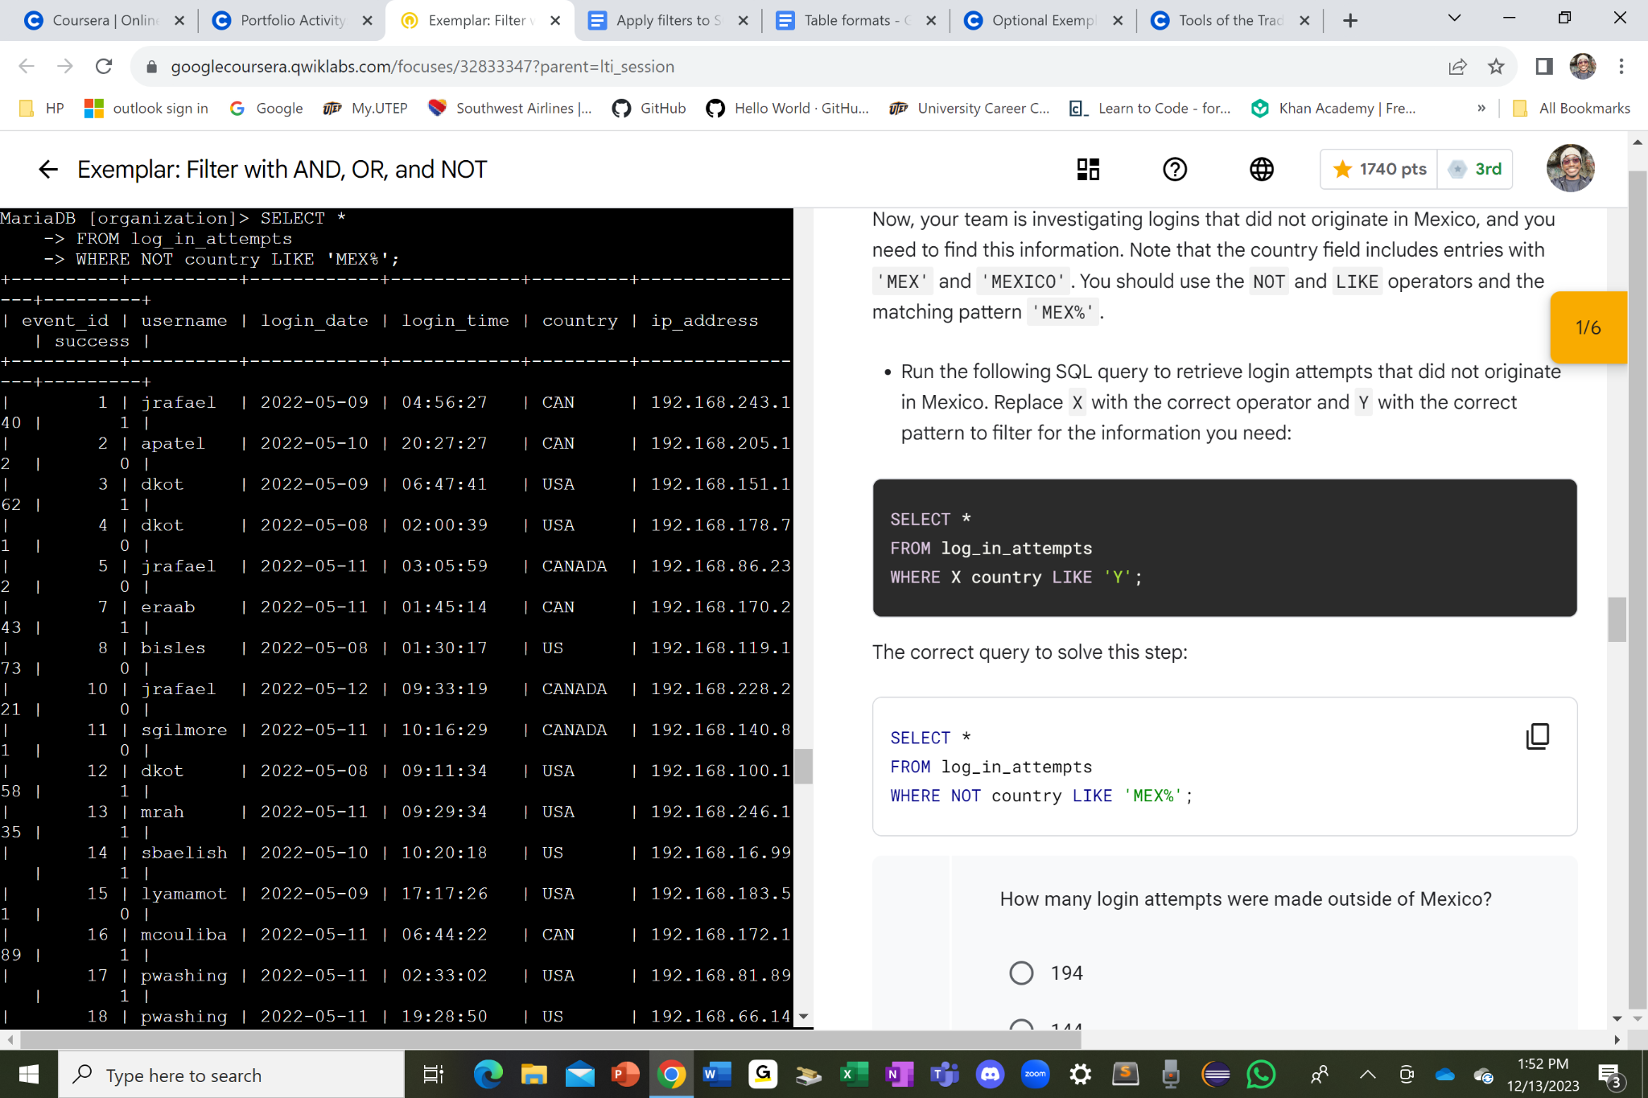

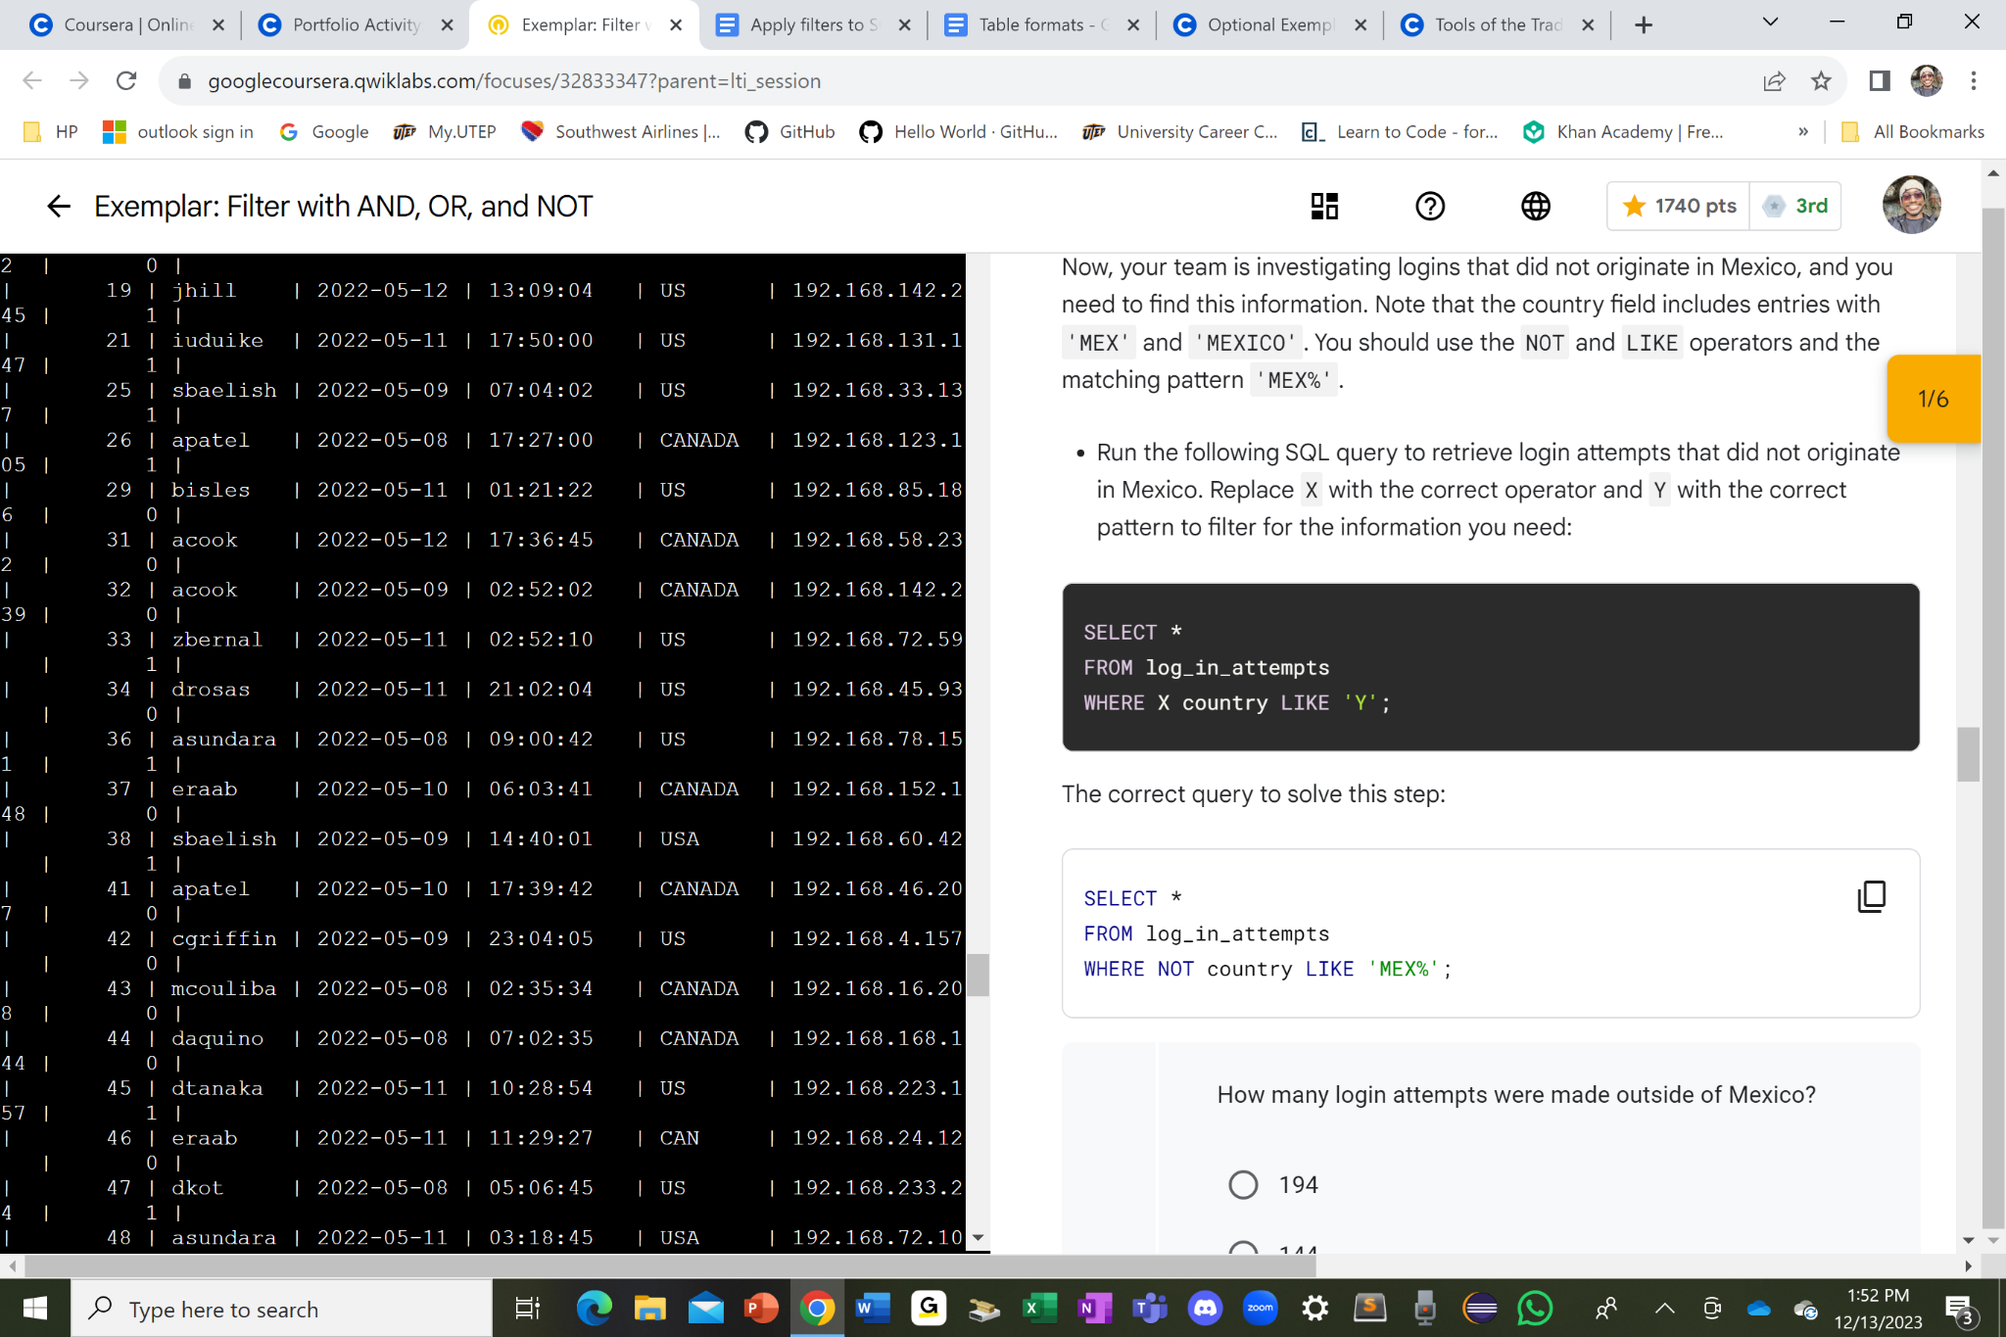

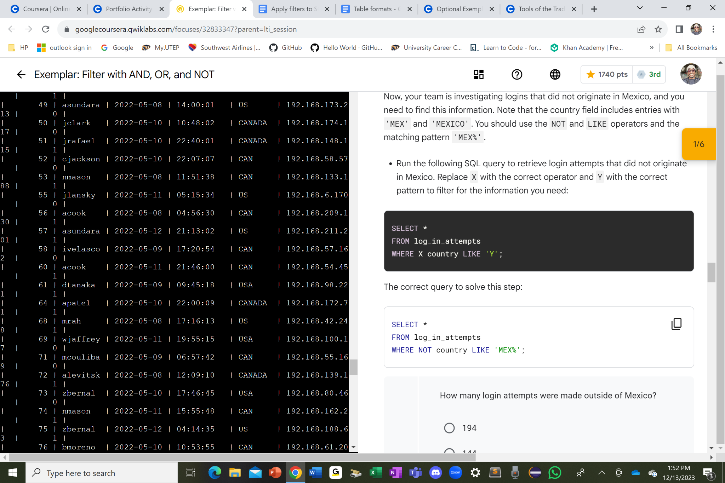

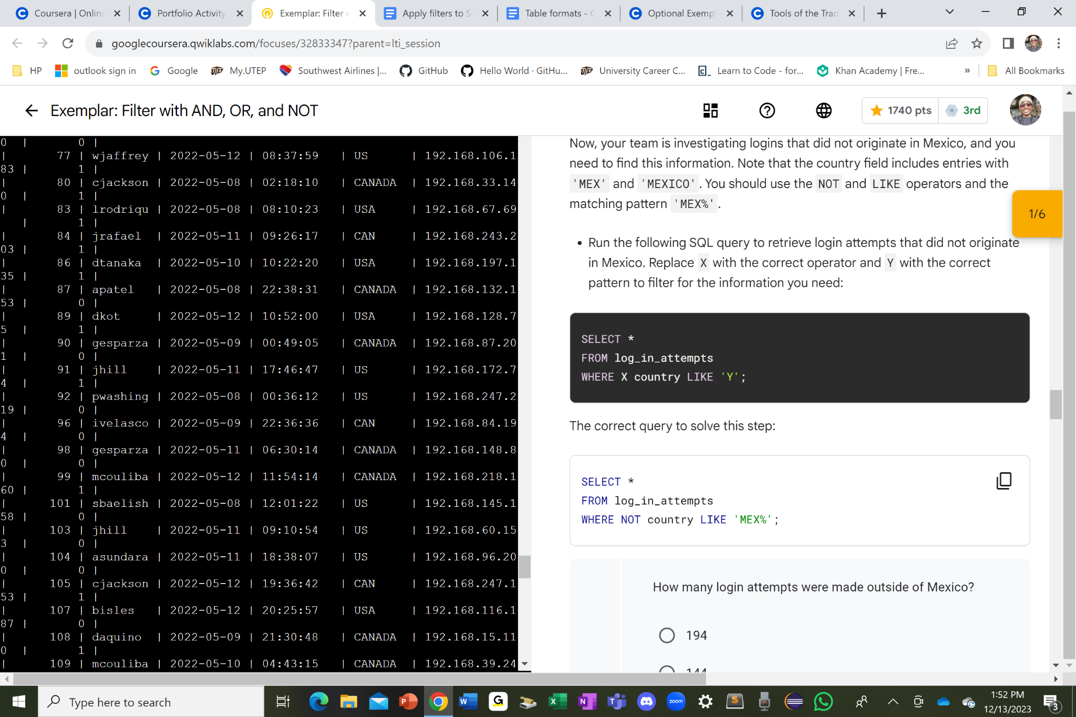

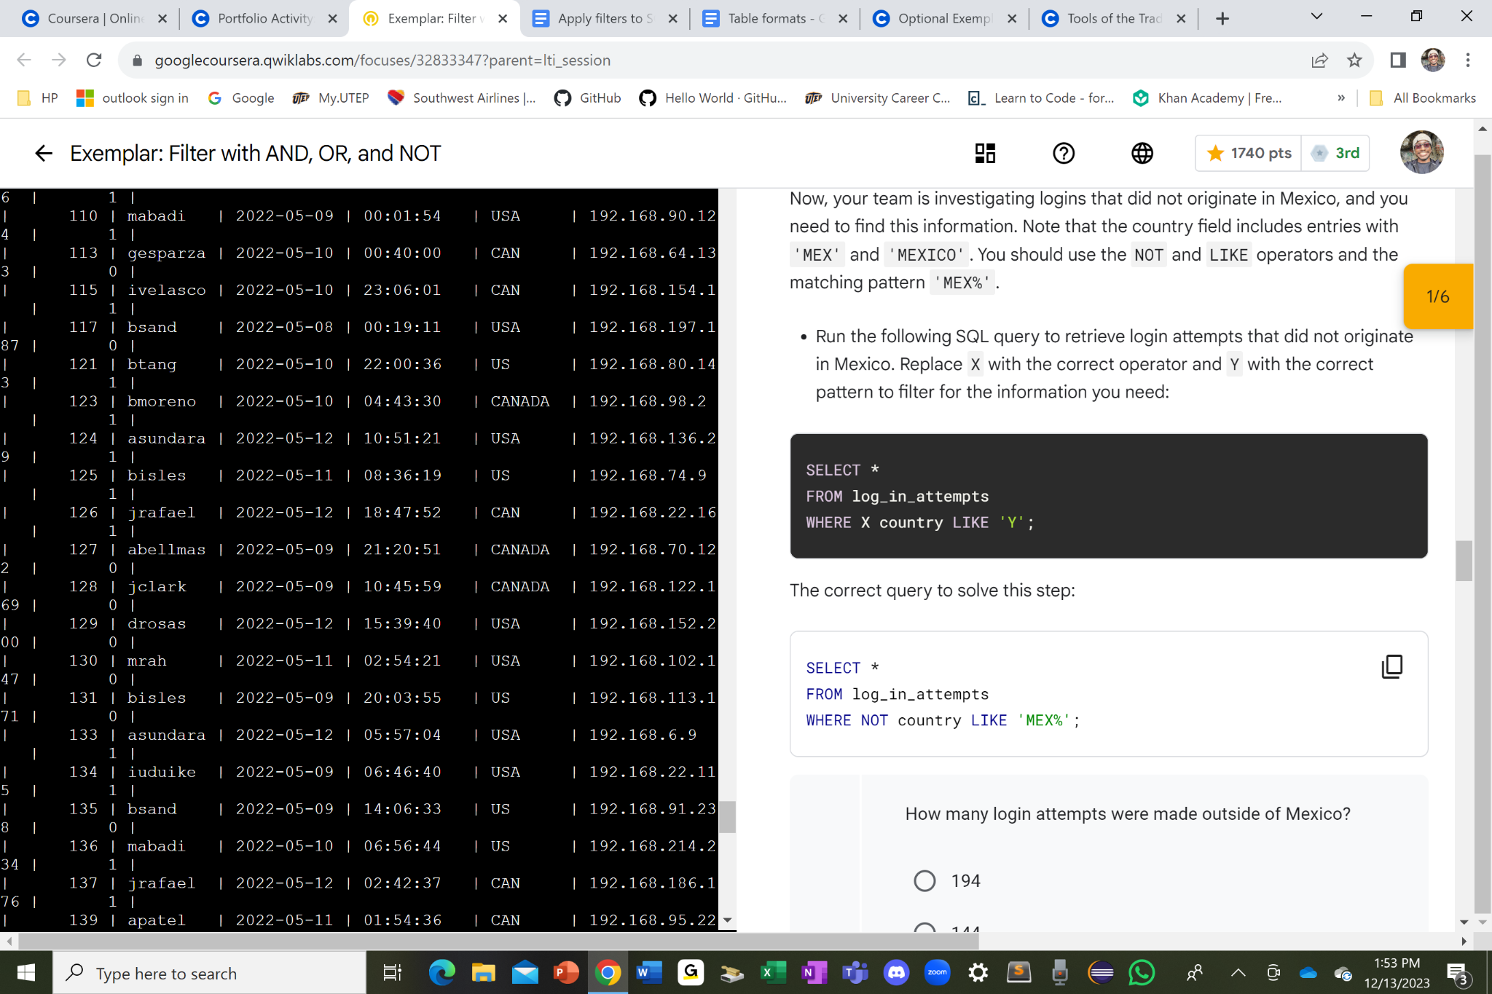

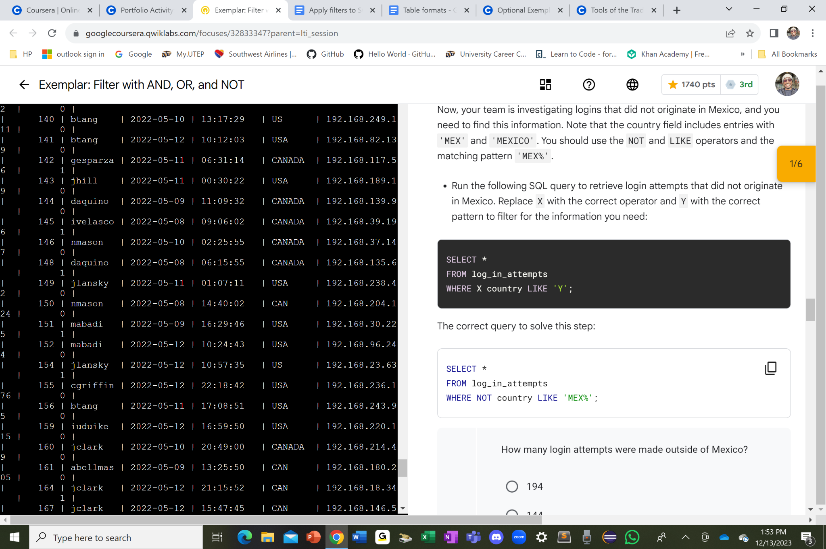

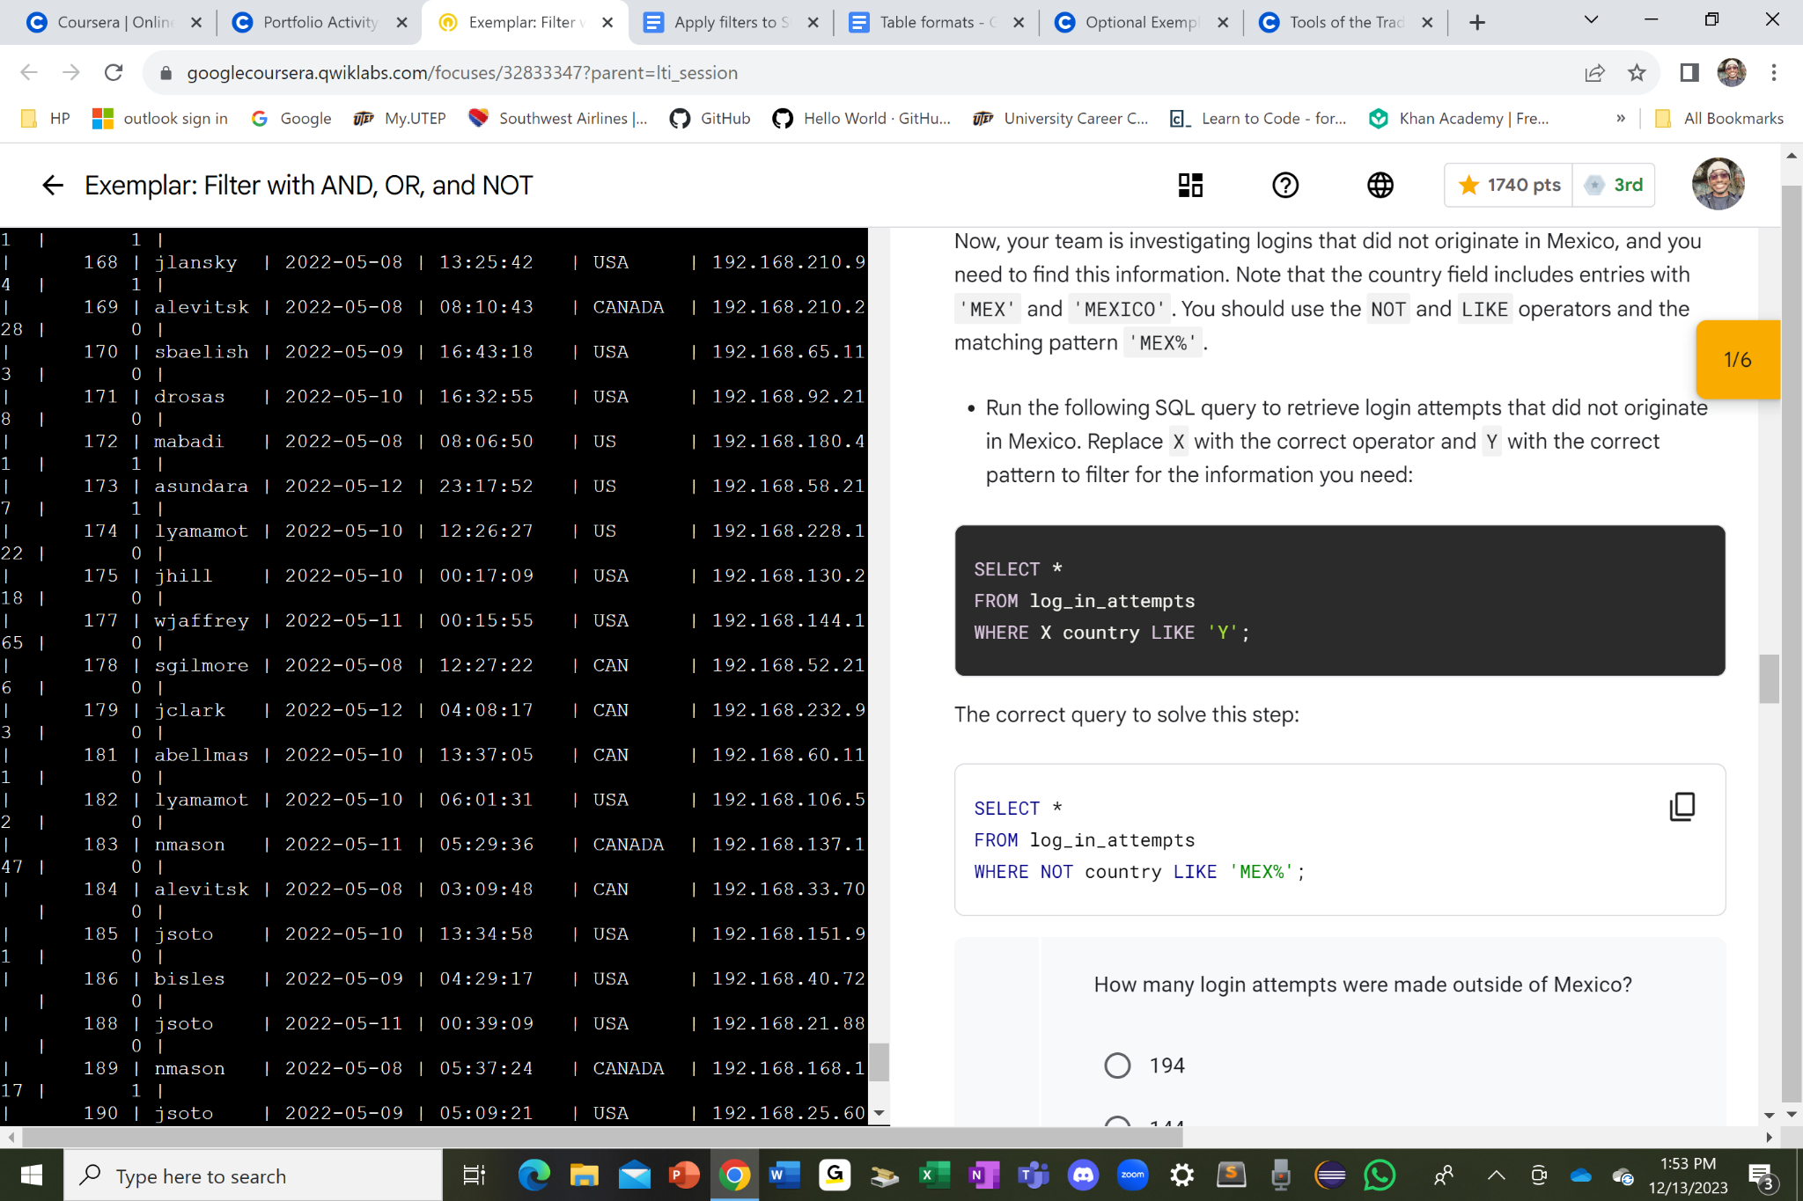

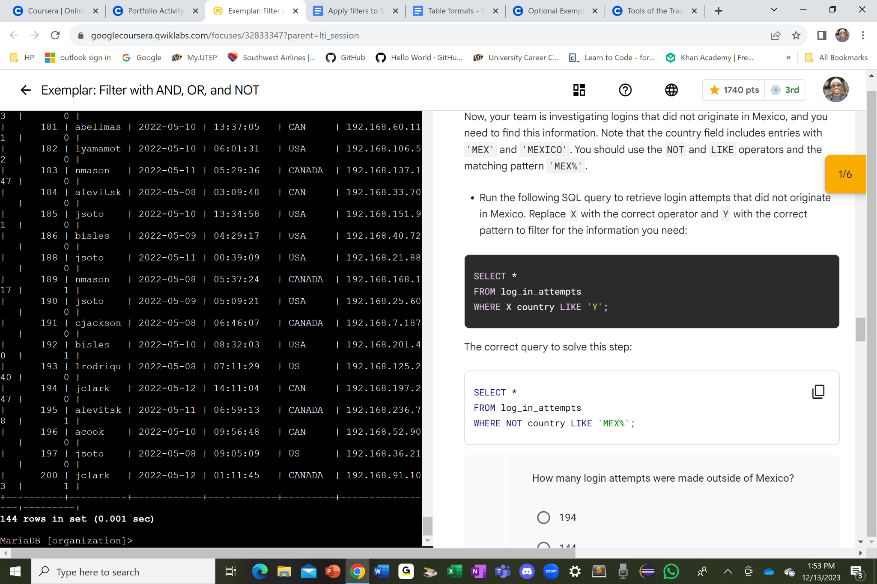

I selected all the columns from the log_in_attempts table by first using the SELECT * command and then the FROM log_in_attempts command. For the WHERE clause after the two commands, I added the NOT keyword to the country column name and then a LIKE keyword to pick up any countries that starts with ‘MEX’ by including the ‘MEX%’ command, which the percent sign after the key abbreviation ‘MEX’ represents the rest of the letters right after it.

## Retrieve employees in Marketing

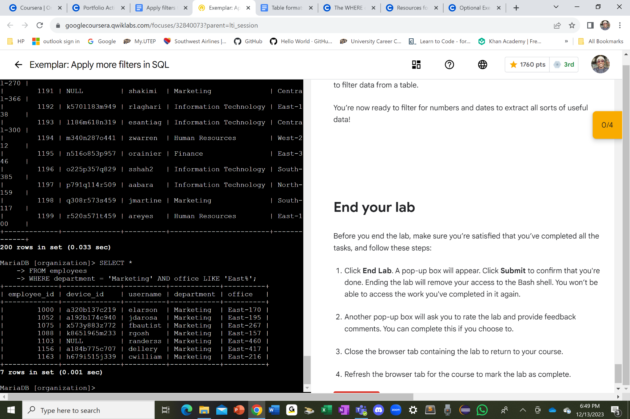

I used the SELECT * command to collect all the columns from the employees table as shown in the FROM employees command after the SELECT clause. From there, I used the WHERE clause to show only the rows of the Marketing department with the department = ‘Marketing’ command followed by an AND keyword gearing towards the office column showing only the sections of the office building and the room numbers only starting with ‘East’ with the ‘East%’ command. The percent sign after the East abbreviation is the rest of the numbers or characters starting with the East abbreviation.

## Retrieve employees in Finance or Sales

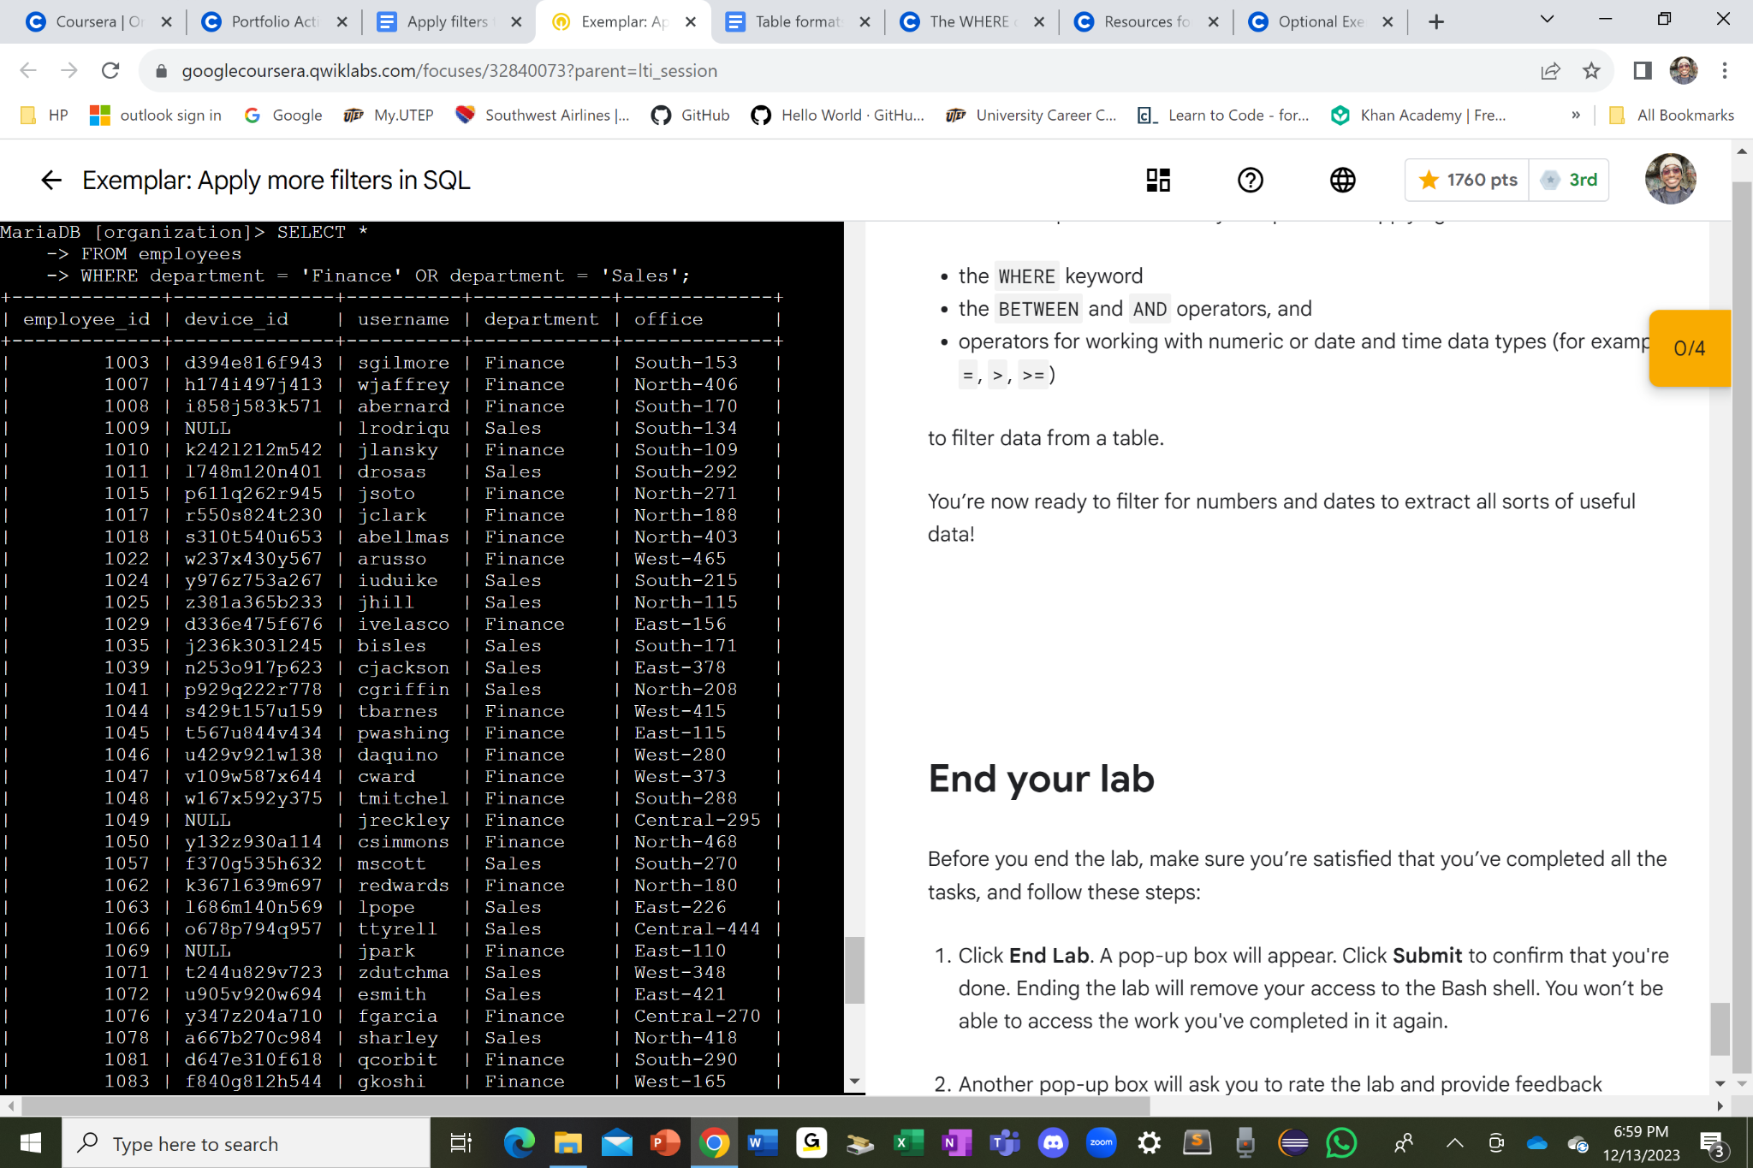

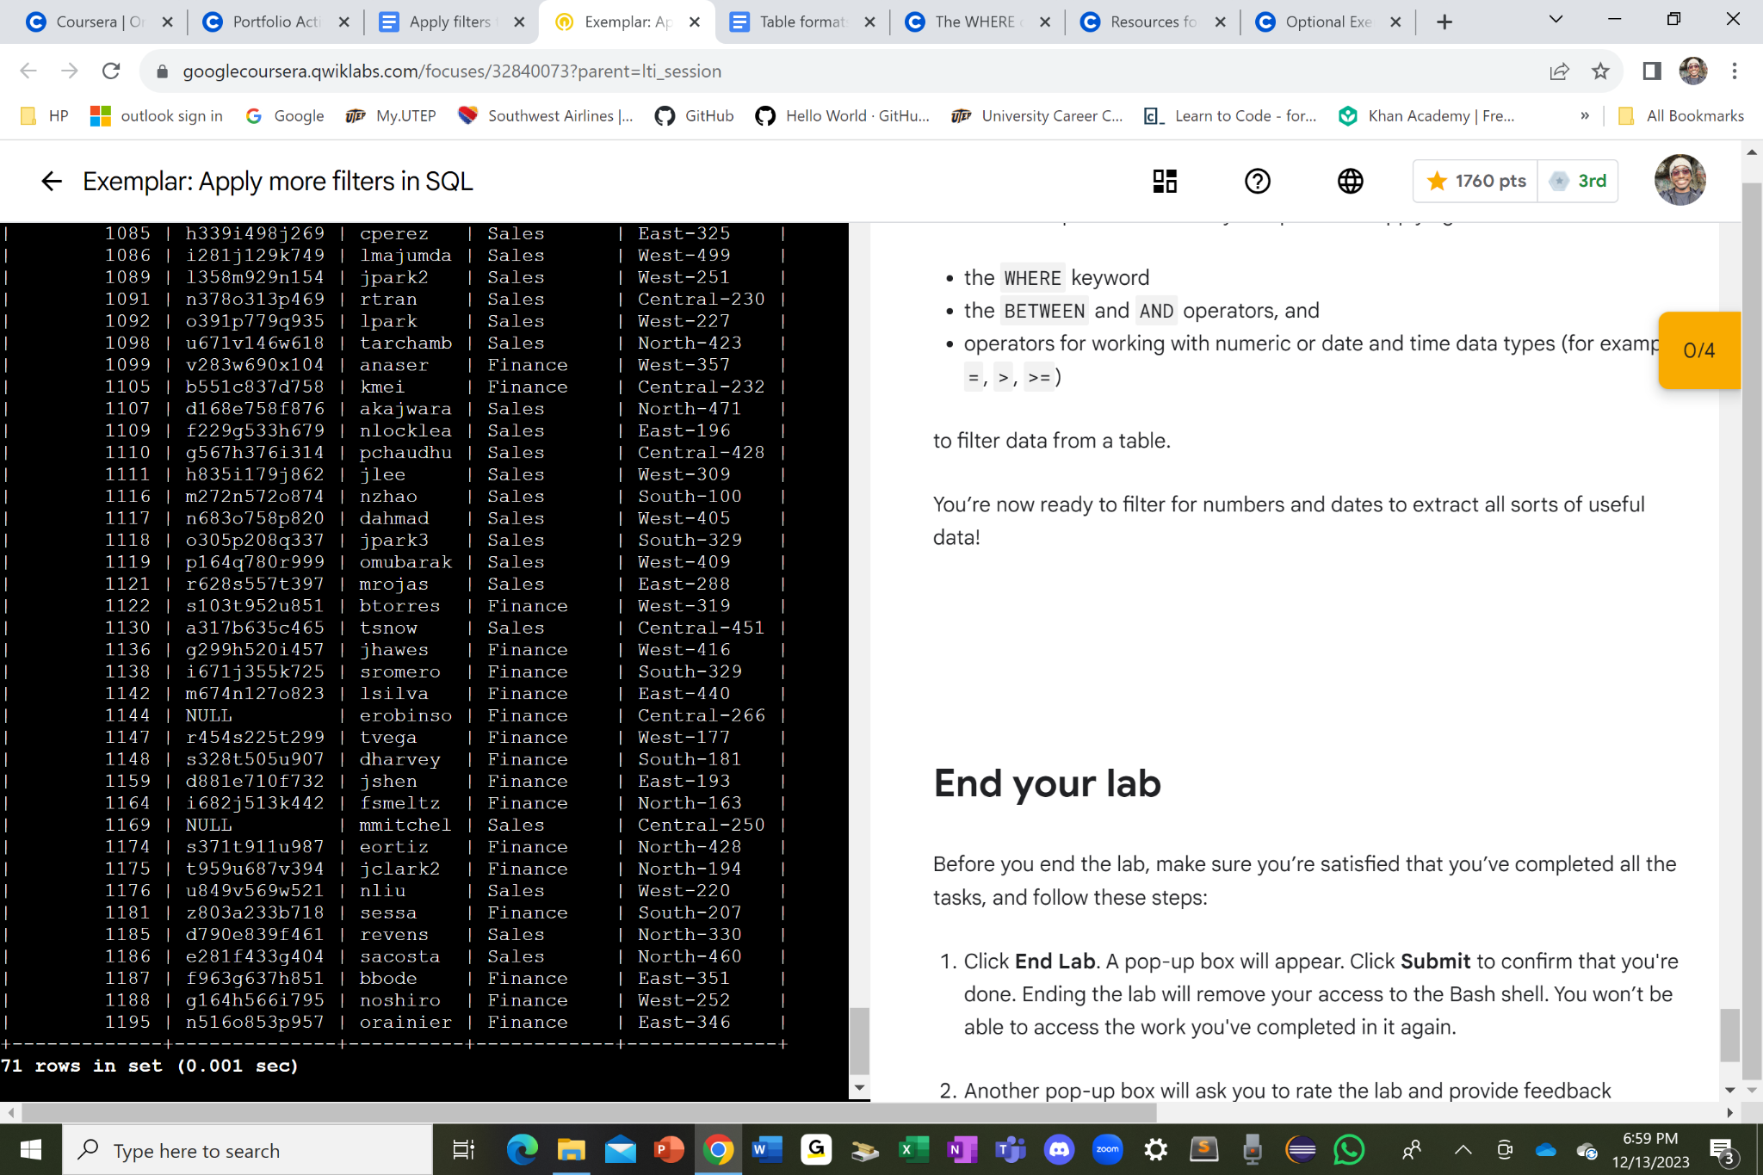

I used the SELECT * command and then the FROM employees command to select all the columns from the employees table. From there, I used the WHERE clause to only show either the Finance department or the Sales department which displays only the employees in either the Finance or in the Sales department tables but not other types of departments other than FInance or the Sales department with the department = ‘Finance’ OR department = ‘Sales’ command.

## Retrieve all employees not in IT

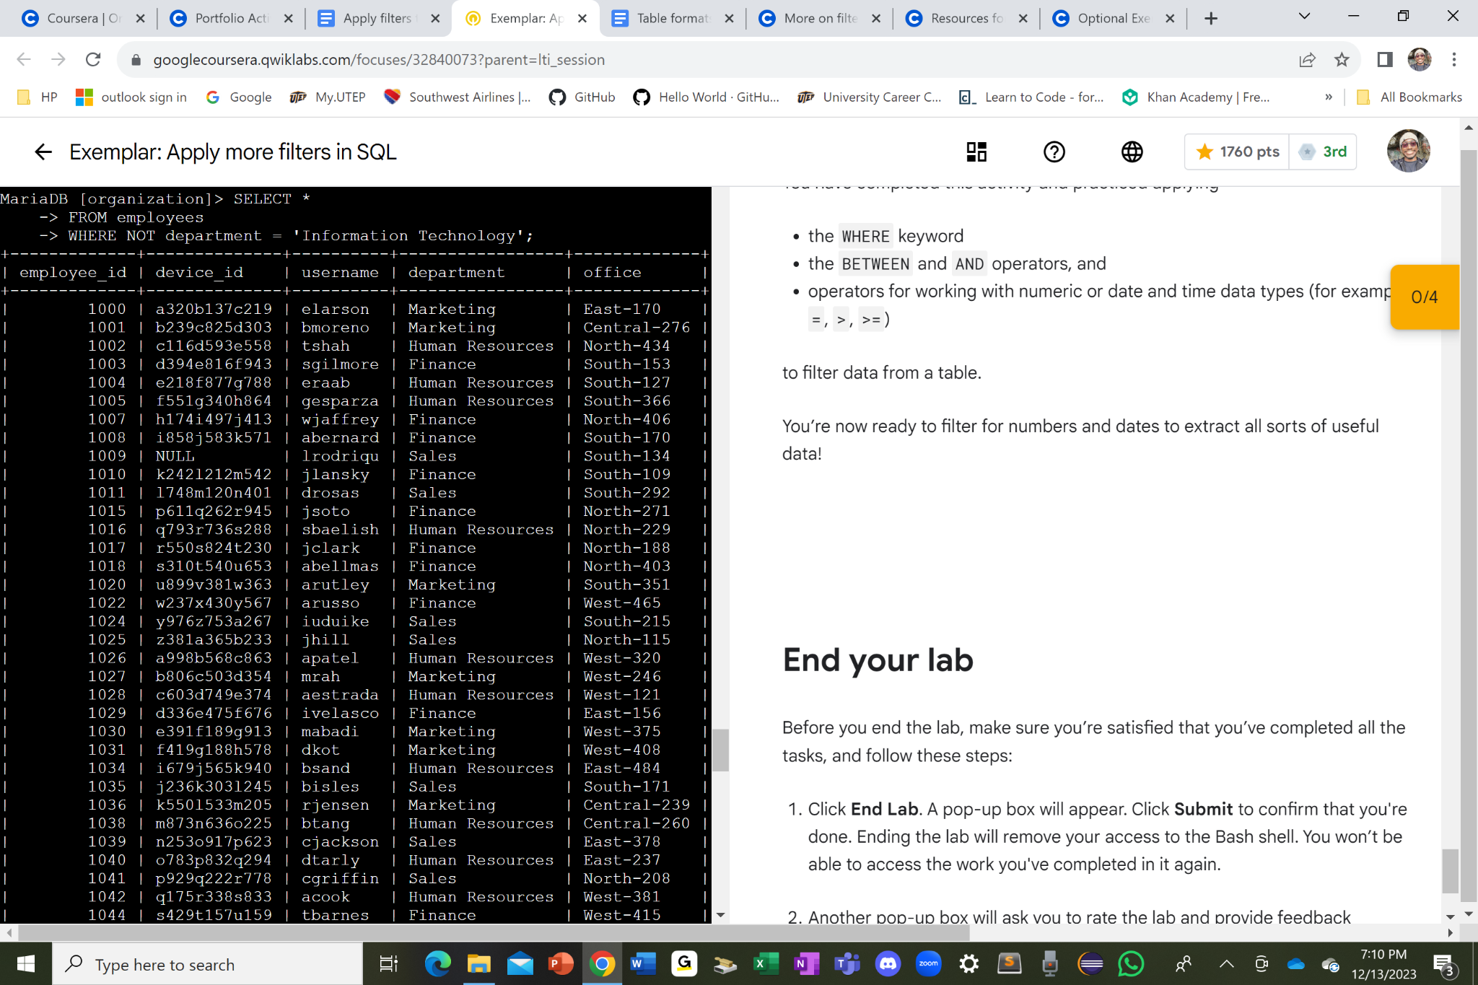

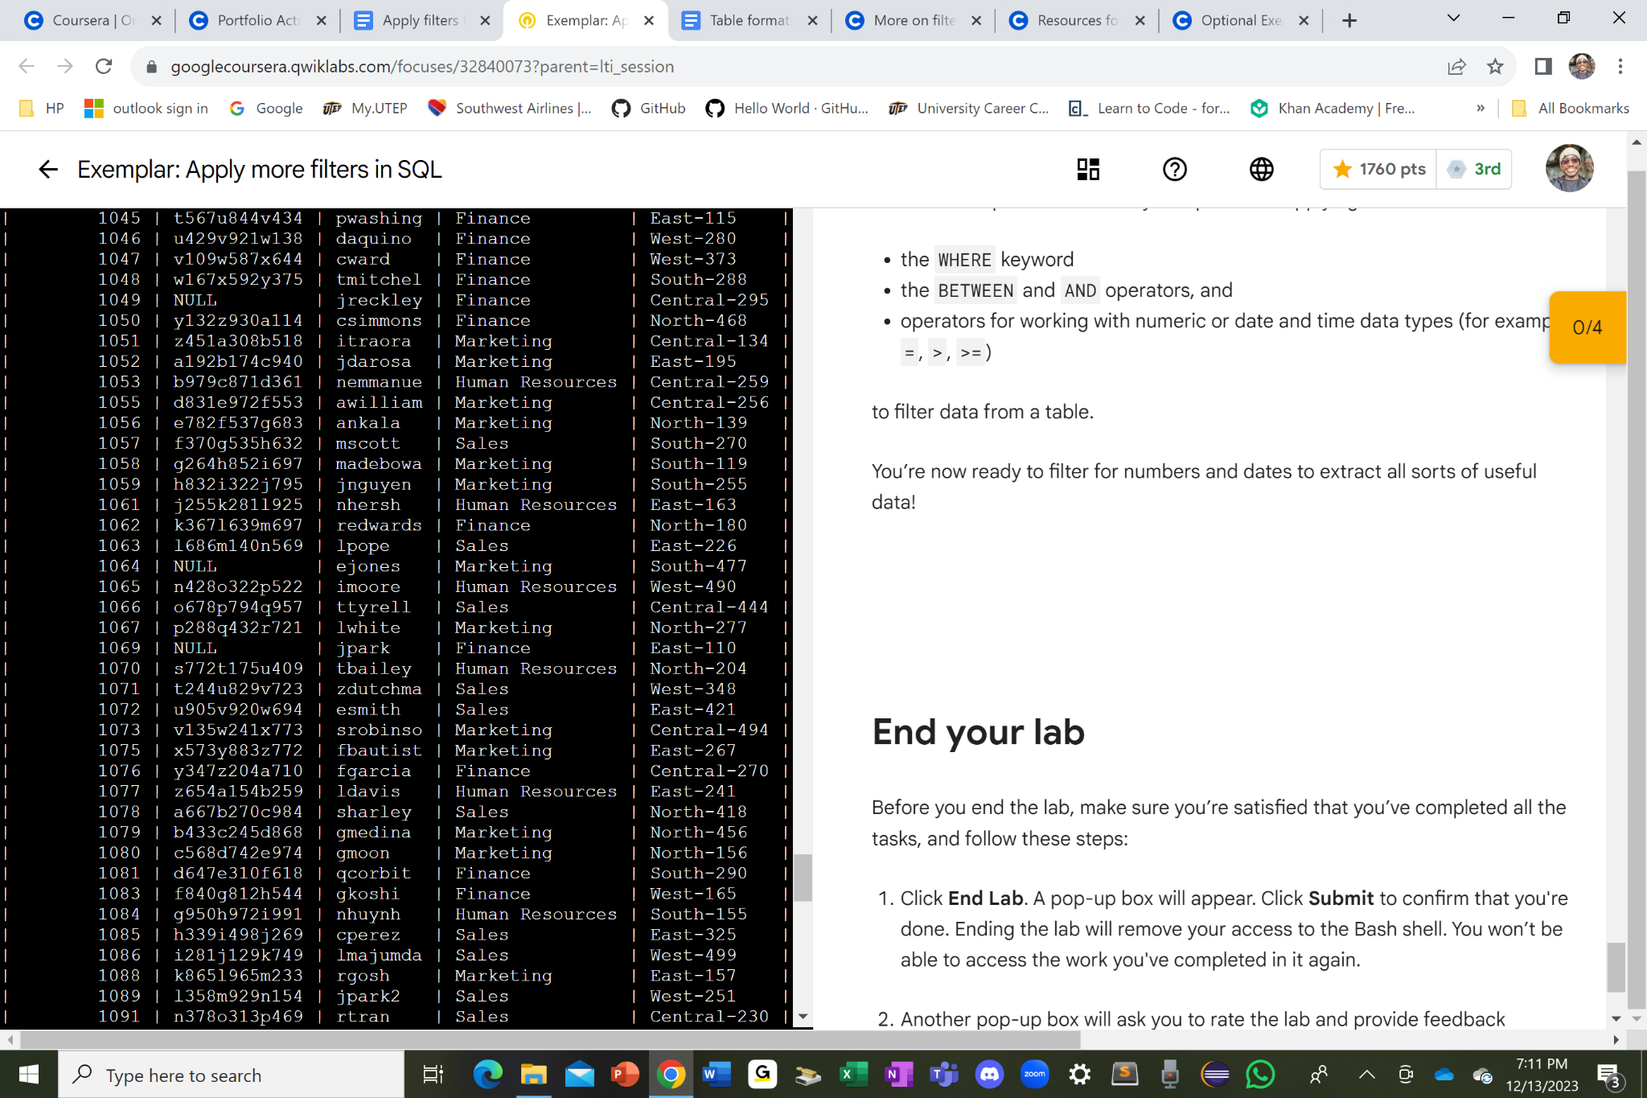

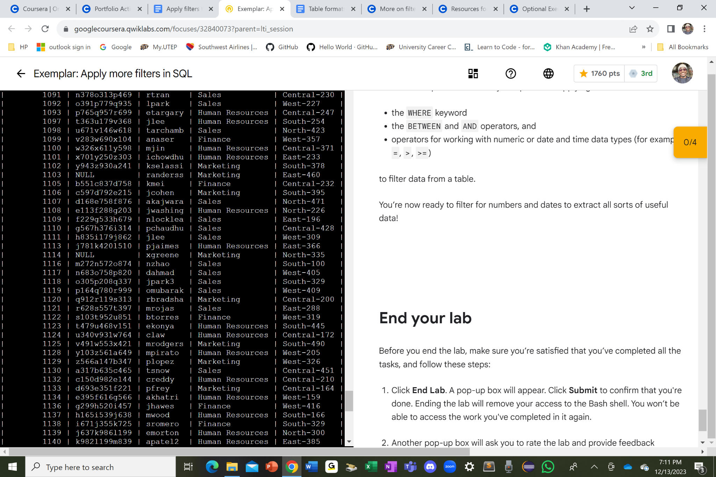

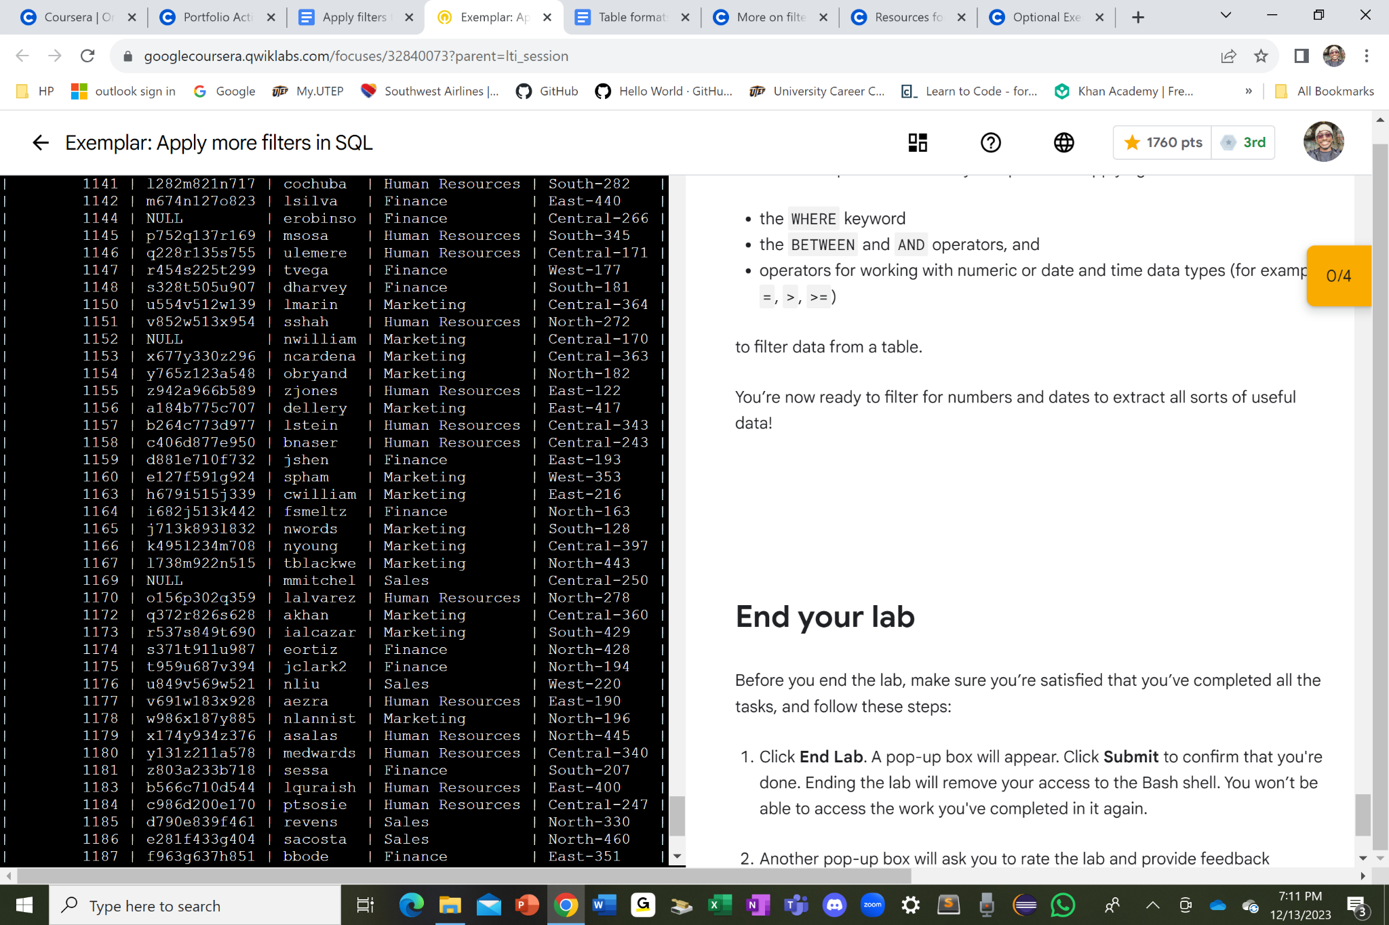

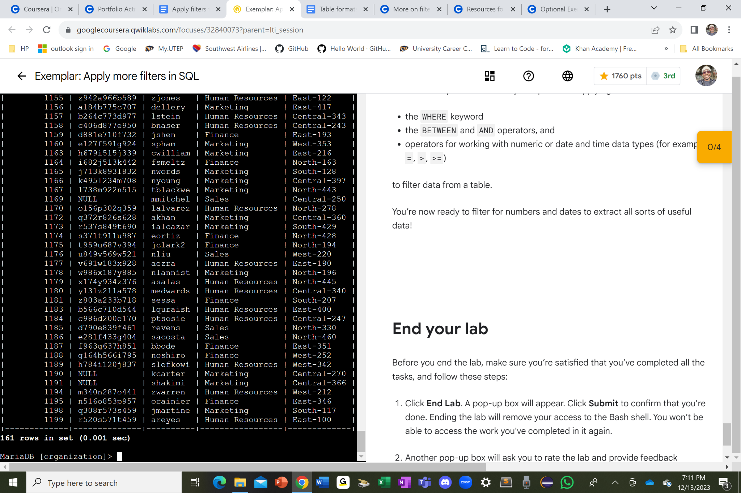

I used the SELECT * command and then the FROM employees command to select all the columns from the employees table. From there, I used the WHERE NOT department = ‘Information Technology’ with a semicolon “ ; ” in the end to run all the commands to show only the departments that are not IT. So it just shows some other types of departments instead.

## Summary

I successfully retrieved records from different datasets and identified the potential security issues with the help of SQL filters and the organization’s system is more secure as a result of it. Therefore, we can stop fake users from entering in the database with the help of tracking down failed login attempts and to identify the users who have access to the employees' machines in a particular location from each department building sections along with room numbers.